**4 System Architecture**

**4.1 Software and Hardware architecture (Diagram)**

**Software:**

*When a user makes a http/https request on the browser to the web application Custom Route Handler handles the route and point Controller in which we write business logic and request data from model. After that controller returns rendered due to user as response.*

**Hardware:**

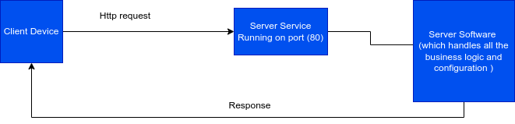

*When a client Device such as mobile phone, desktop, laptop etc makes http/https request service running on the service on a specific port (generally web server is hosted on port 80) handles the request with the help of Server Software, executes business logic and returns the response.*